INFLATABLE PACKERS

Pipe repair inflatable packers

*Suitable for the sectional repair with a combination of the silicate 3P resin and CRF+ fiberglass. The end result gives an excellent mechanical, chemical and temperature resistance patch long up to 5m.*

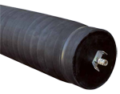 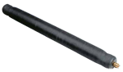 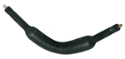

|  |  |  |  |  |
| --- | --- | --- | --- | --- |
| NAME | FLEXIBLE PACKERS | LONG PACKERS | LATERAL PACKERS | T-90 PACKER |
| DESCRIPTION | This style of packer is used for the partial repair of damaged Main pipelines. It works in combination with artificial resins and strengthening materials, ensuring repeated tightness and suitable static tightness of the packer. | Are equipped with a fast coupling for quick filling and emptying and they contain two lifting bolts, to allow for tying on rope to assist with the process of installation, transporting and pulling the packer out of the pipeline. | Are used for repairing small diameter pipes. Suitable for Household lateral installations. Packers are rounded on both sides so that they slip around the bends much easier during installation. | This Packer is intended for repair works around 45, 60 & 90 degree bends. They are made of special materials, which allows them to be flexible enough to easily get around bends. |
| SIZE OPTIONS (mm) | from 100 to 1200 | from 200 to 800 | from 35 to 400 | from 70 to 205 |
| LENGTH (m) | from 1 to 5 | from 1 to 5 | from 1 to 5 | 1m |